**EXPERIMENT–7**

**Objective:** To create component diagram for

1. Railway management system
2. Library management system

**Hardware/Software Requirements:** Star UML

**Theory:** Component diagrams are different in terms of nature and behavior. Component diagrams are used to model the physical aspects of a system. Physical aspects are the elements such as executables, libraries, files, documents, etc. which reside in a node. Component diagrams are used to visualize the organization and relationships among components in a system. These diagrams are also used to make executable systems.

1. **Railway Management System**

**Diagram:**

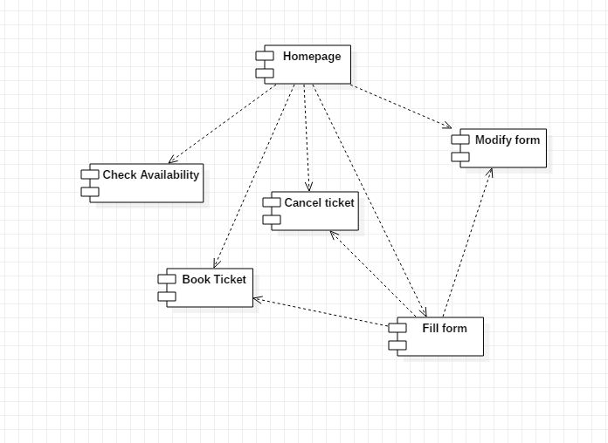

1. **Library Management System**

**Diagram:**

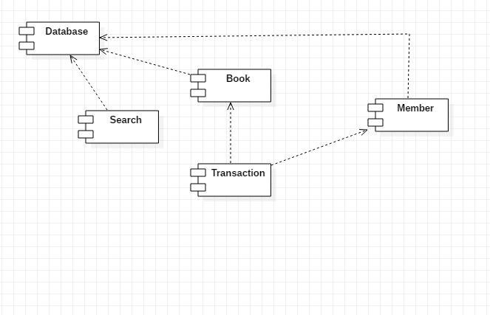

**Description:**

Component diagram is a different in terms of nature and behavior. Component diagrams are used to model physical aspects of a system. Component diagram are used to visualize the organization and relationship among component of a system.

Component diagram is a special kind of diagram in UML. The purpose is also different from all other diagrams discussed so far. It does not describe the functionality of the system, but it describes the component used to describe that functionality.

Component diagrams can also be described as the static implementation view of a system. Static implementation represents the organization of the components at a moment.

A single component diagram cannot represent the entire system, but a collection of diagrams is used to represent the whole.

So, the purpose of the component diagram can be summarized as:

* Visualize the components of the system.
* Construct executable by using forward and reverse engineering.
* Describe the organization and relationship of the components

|  |  |  |  |
| --- | --- | --- | --- |
| Program | B.Tech CSE | Course Name | Software Engineering |
| Course Code | IT301 | Semester | 5 |
| Student Name | **TUSHITA SINHA** | Enrollment Number | **A12405216108** |

|  |
| --- |
| **Internal Assessment (Mandatory Experiment) Sheet For Lab Experiment**  **Department of Computer Science and Engineering**  **Amity University, Noida(UP)** |

|  |
| --- |
| **Marking Criteria** |

|  |  |  |  |
| --- | --- | --- | --- |
| **Criteria** | **Total Marks** | **Marks Obtained** | **Comments** |
| **Concept (A)** | **2** |  |  |
| **Implementation(B)** | **2** |  |  |
| **Performance(C)** | **2** |  |  |
| **Total** | **6** |  |  |

**EXPERIMENT–8**

**Objective:** To create deployment diagram for railway management system

**Hardware/Software Requirements:** Star UML

**Theory: Deployment diagram** is a [structure diagram](https://www.uml-diagrams.org/uml-25-diagrams.html#structure-diagram) which shows architecture of the system as deployment (distribution) of software artifacts to deployment targets.

[Artifacts](https://www.uml-diagrams.org/artifact.html) represent concrete elements in the physical world that are the result of a development process. Examples of artifacts are executable files, libraries, archives, database schemas, configuration files, etc.

[Deployment target](https://www.uml-diagrams.org/deployment-diagrams.html#deployment-target) is usually represented by a [node](https://www.uml-diagrams.org/deployment-diagrams.html#node) which is either hardware device or some software execution environment. Nodes could be connected through [communication paths](https://www.uml-diagrams.org/deployment-diagrams.html#communication-path) to create networked systems of arbitrary complexity. Components are deployed to nodes indirectly through artifacts. Deployment diagrams could describe architecture at **specification level** (also called type level) or at **instance level**.

**Railway Management System**

**Diagram:**

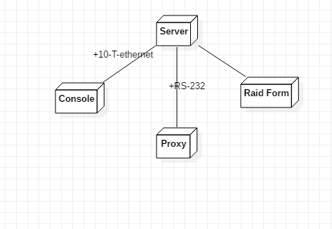

**Description:**

Deployment diagrams are used to visualize the topology of the physical components of a system where the software components are deployed.

So, the diagrams are used to describe the static deployment view of a system. Deployment diagrams consist of nodes and their relationships.

The name Deployment itself describes the purpose of the diagram. Deployment diagrams are used for describing the hardware components where software components are deployed. Component diagrams and deployment diagrams are closely related.

Component diagrams are used to describe the components and deployment diagrams show how they are deployed in hardware.

UML is mainly designed to focus on software artifacts of a system. But these two diagrams are special diagrams used to focus on software components and hardware components.

So, most of the UML diagrams are used to handle logical components but deployment diagrams are made to focus on hardware topology of a system. Deployment diagrams are used by the system engineers. The purpose of deployment diagrams can be

* Visualize hardware topology of a system.
* Describe the hardware components used to deploy software components.
* Describe runtime processing nodes.

|  |  |  |  |
| --- | --- | --- | --- |
| Program | B.Tech CSE | Course Name | Software Engineering |
| Course Code | IT301 | Semester | 5 |
| Student Name | **TUSHITA SINHA** | Enrollment Number | **A12405216108** |

|  |
| --- |
| **Internal Assessment (Mandatory Experiment) Sheet For Lab Experiment**  **Department of Computer Science and Engineering**  **Amity University, Noida(UP)** |

|  |
| --- |
| **Marking Criteria** |

|  |  |  |  |
| --- | --- | --- | --- |
| **Criteria** | **Total Marks** | **Marks Obtained** | **Comments** |
| **Concept (A)** | **2** |  |  |
| **Implementation(B)** | **2** |  |  |
| **Performance(C)** | **2** |  |  |
| **Total** | **6** |  |  |